ServiceNow Integration with Google Gemini
Google Gemini is an advanced AI initiative by Google, representing the next generation of large language models (LLMs) and AI capabilities. Officially unveiled in December 2023, Gemini is designed to be a more powerful and versatile successor to previous models like Google Bard and OpenAI's ChatGPT.
Step 1: Gemini supports API Key Authentication.
Go on browser and Search for google Gemini Api key or just click on the below link.
https://ai.google.dev/gemini-api/docs/api-key
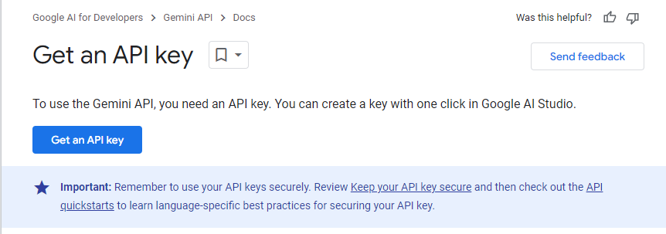
Step 2: Click on Get an API Key.
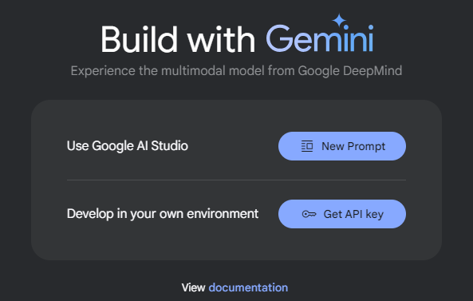

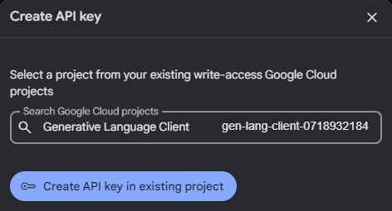
Create API Key and copy that.
Step 3: Scroll down on the same page you will see a quick test cURL Command.
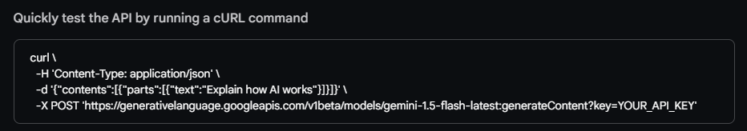In this command you will see all the necessary things you all want for the Integration i.e.
1.Endpoint 2.Payload 3.Authentication (API Key)
#NOTE: You can test your connectivity using Postman.
- ENDPOINT:
https://generativelanguage.googleapis.com/v1beta/models/gemini-1.5-flash-latest:generateContent?key=YOUR_API_KEY
- PAYLOAD:
{"contents":[{"parts":[{"text":"Explain how AI works"}]}]}
- METHOD:
POST
- AUTHENTICATION:
API Key

Step 4: Now open your ServiceNow Instance and create a Rest Message.
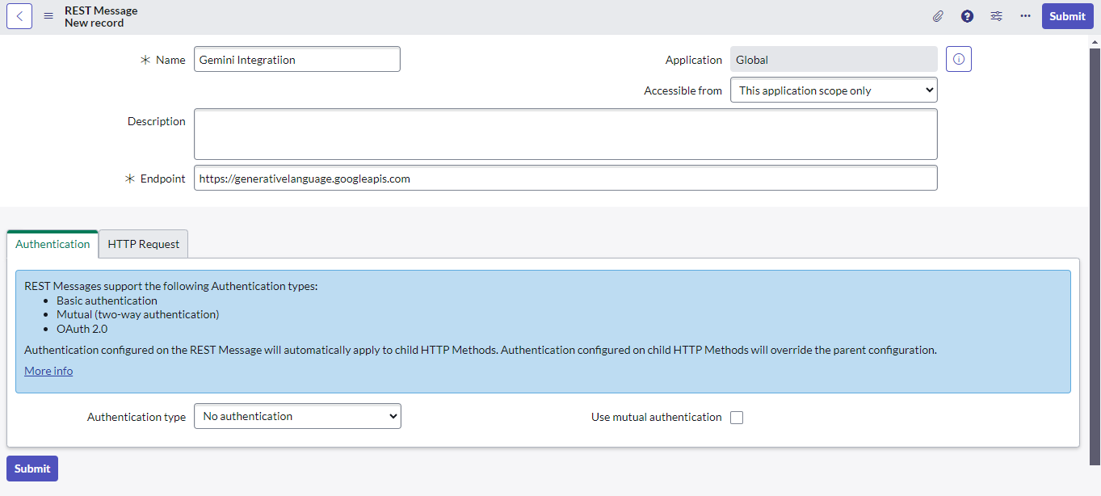
Enter base URL here.
Now Create a POST Method.
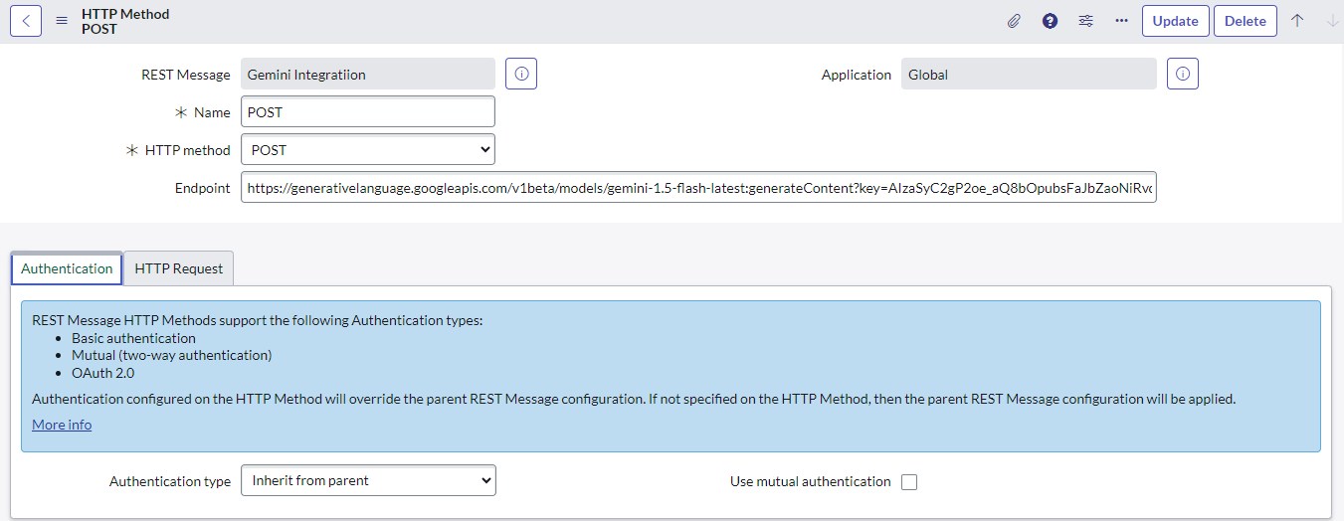

Step 5: Create Header Parameter and give Content.
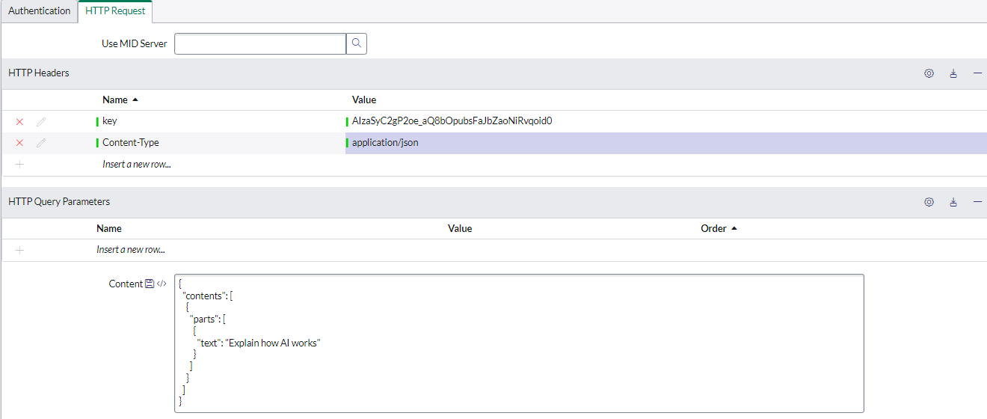Now click on Test Related Link.
Your Api Key Here.
Payload Here.
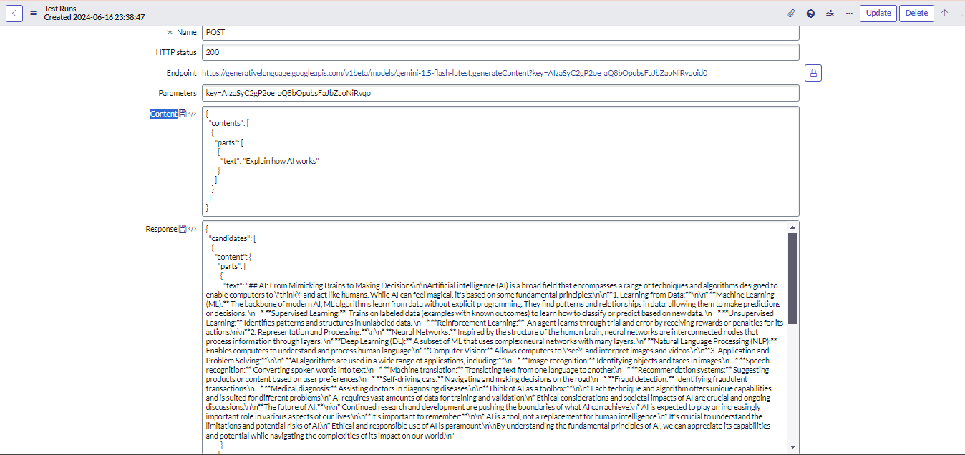Connection Successful.
Connection Succesfull.
Response Body.
Copy the script using Related Link Preview Script Usage.

1.Create a table with two fields. When a user enters a new record and asks a question, the response to that question is automatically entered into the other field.
Step1: Create a table having 2 fields.
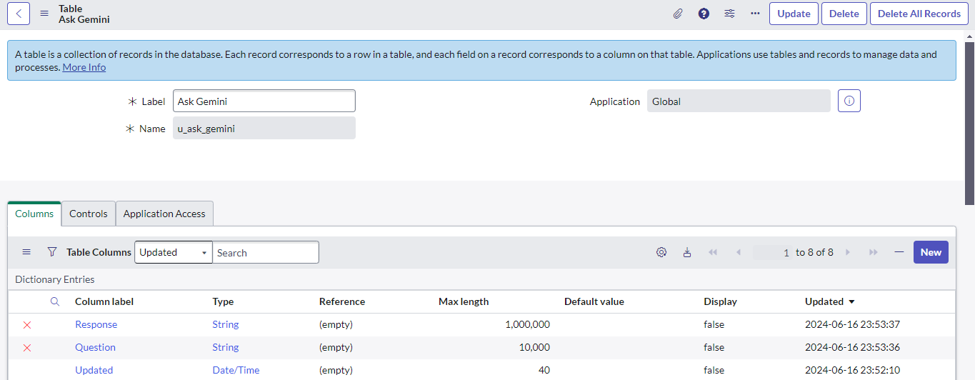Step 2: Create a before Insert Business Rule with when to run condition Question is not Empty and paste the script copied earlier in the script Section.
In this field you will enter your question.
In this field you will get your Response.
(function executeRule(current, previous /*null when async*/ ) {
try {
var body = JSON.stringify({
"contents": [{
"parts": [{
"text": current.u_question.toString()
}]
}]
});
var r = new sn_ws.RESTMessageV2('Gemini Integratiion', 'POST');
r.setRequestBody(body);
var response = r.execute();
var responseBody = response.getBody();
var res=JSON.parse(responseBody);
current.u_response=res.candidates[0].content.parts[0].text;
var httpStatus = response.getStatusCode();
} catch (ex) {
var message = ex.message;
}

})(current, previous);
Now Create a new record on the table ask whatever you want.
Example 1:
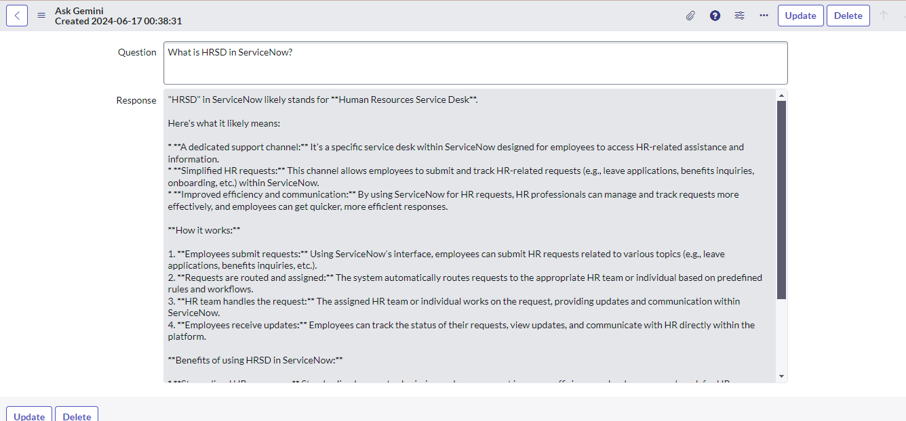Example 2:
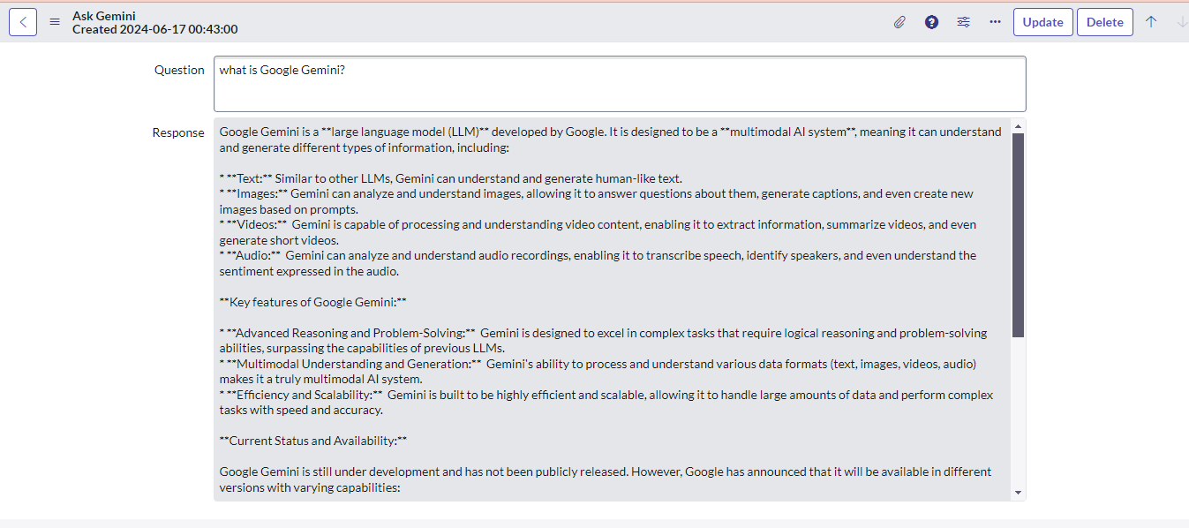

2.Ask Your Questions using Virtual Agent.
Step1: Create a new Topic in Virtual Agent Designer.
All>Conversational Interfaces>Designer >Create
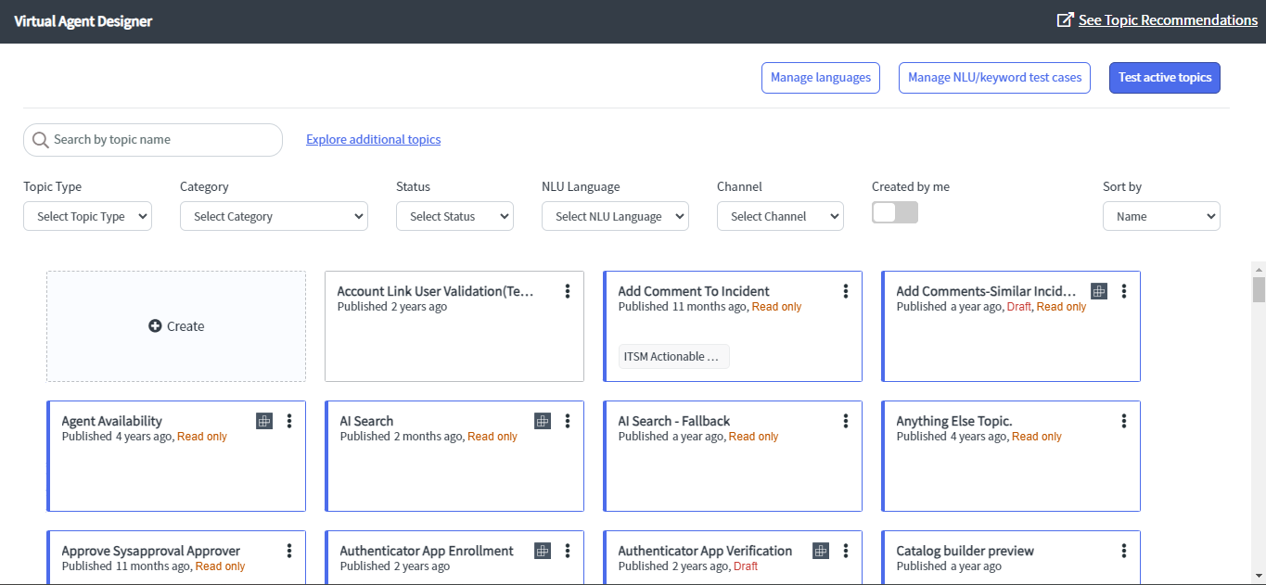
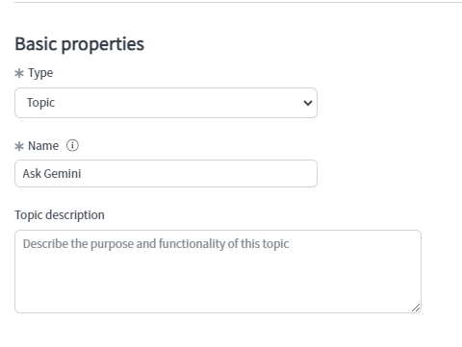
Enter Name of the Topic.

Create a new NLU Model or if you already have one used that and create a new Intent for this particular Topic.
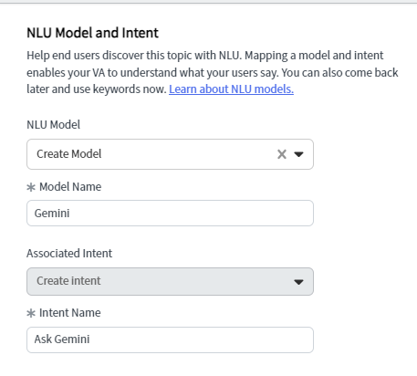
Why we have to create NLU or Intents.
Now add some Keywords
Keywords: Words or phrases that users enter to initiate a conversation about the topic. The Virtual Agent Designer automatically adds the Name of the topic as a keyword. Resume topic flow: Toggle to allow a conversation to resume when Natural Language Understanding (NLU) is enabled.
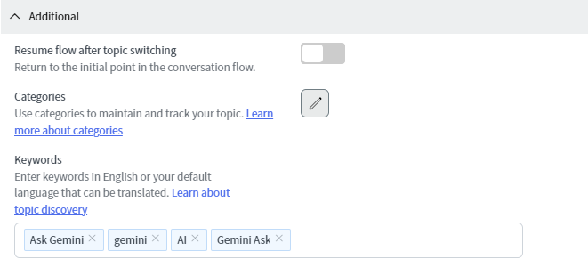
Step 2: Create Flow
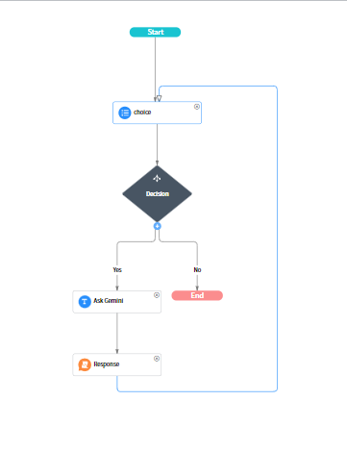
In this flow first it will ask if you want to ask something.
If Yes:
It will ask you what do you want to ask.
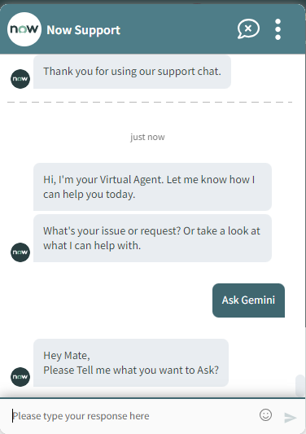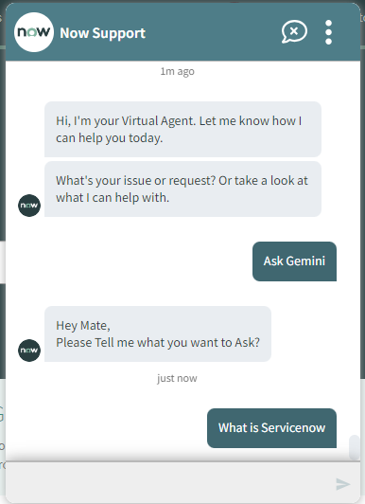
Then we have used Bot Response Script.
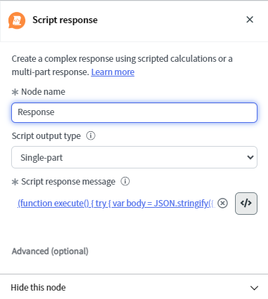
Here we called a Rest Message which I had created Earlier.
Script :
(function execute() {
try {
var body = JSON.stringify({
"contents": [{
"parts": [{
"text": vaInputs.ask_gemini.getValue()
}]
}]
});
gs.log("Hii23"+body);
var r = new sn_ws.RESTMessageV2('Gemini Integratiion', 'POST');
r.setRequestBody(body);

var response = r.execute();
var responseBody = response.getBody();
var res=JSON.parse(responseBody);
var httpStatus = response.getStatusCode();
return res.candidates[0].content.parts[0].text;
} catch (ex) {
var message = ex.message;
}
})()

#NOTE: To use the value of input (from Ask Gemini Node): We have used Inputs variables.
To get the value: vaInputs.ask_gemini.getValue()
For more details visit: Click Here.
Here we get the response:
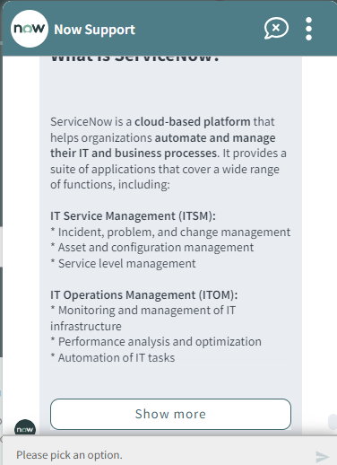

It will ask if you want to ask further more questions or not.
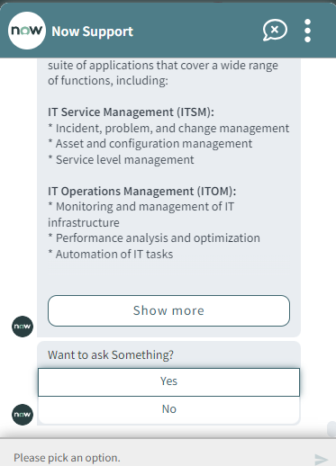
- If No:
It will end the conversation.

